ASSIGNMENT No: 03
Title: Perform the Extraction Transformation and Loading (ETL) process to construct the database in the Sql server / Power BI.
Problem Statement: Perform the Extraction Transformation and Loading (ETL) process to construct the database in the Sql server / Power BI.
Prerequisite:
Basics of Python
Software Requirements: Jupyter
Hardware Requirements:
PIV, 2GB RAM, 500 GB HDD
Learning Objectives:
Learn to Perform the Extraction Transformation and Loading (ETL) process to construct the database in the Sql server / Power BI.
Outcomes:
After completion of this assignment students are able to understand how to Perform the Extraction Transformation and Loading (ETL) process to construct the database in the Sql server / Power BI.
Theory:

Step 1 : Data Extraction :

The data extraction is first step of ETL. There are 2 Types of Data Extraction

- Full Extraction : All the data from source systems or operational systems gets extracted to staging area. (Initial Load)

- Partial Extraction : Sometimes we get notification from the source system to update specific date. It is called as Delta load.

Source System Performance: The Extraction strategies should not affect source system performance.

Step 2 : Data Transformation :

The data transformation is second step.After extracting the data there is big need to do the transformation as per the target system.I would like to give you some bullet points of Data Transformation.

- Data Extracted from source system is in to Raw format. We need to transform it before loading in to target server.
- Data has to be cleaned, mapped and transformed.
- There are following important steps of Data Transformation :
- Selection : Select data to load in target

- Matching : Match the data with target system

- Data Transforming : We need to change data as per target table structures

Real life examples of Data Transformation :

  - Standardizing data : Data is fetched from multiple sources so it needs to be standardized as per the target system.
  - Character set conversion : Need to transform the character sets as per the target systems. (Firstname and last name example)
  - Calculated and derived values: In source system there is first val and second val and in target we need the calculation of first val and second val.
  - Data Conversion in different formats : If in source system date in in DDMMYY format and in target the date is in DDMONYYYY format then this transformation needs to be done at transformation phase.
Step 3 : Data Loading
  - Data loading phase loads the prepared data from staging tables to main tables.

ETL process in SQL Server:

Following are the steps to open BIDS\SSDT.

Step 1 − Open either BIDS\SSDT based on the version from the Microsoft SQL Server programs group. The following screen appears.

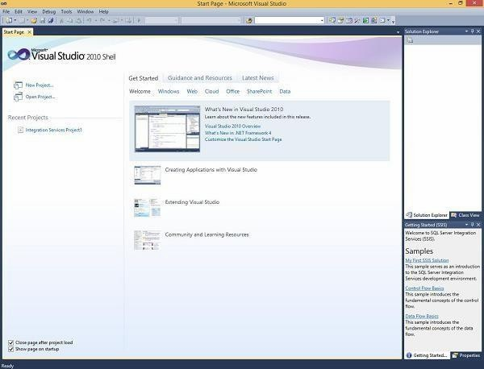

Step 2 − The above screen shows SSDT has opened. Go to file at the top left corner in the above image and click New. Select project and the following screen opens.

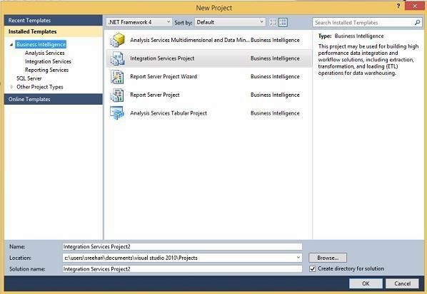

Step 3 − Select Integration Services under Business Intelligence on the top left corner in the above screen to get the following screen.

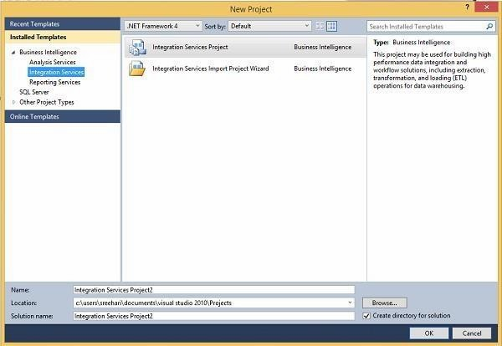
Step 4 − In the above screen, select either Integration Services Project or Integration Services Import Project Wizard based on your requirement to develop\create the package.

Modes
There are two modes − Native Mode (SQL Server Mode) and Share Point Mode.

Models
There are two models − Tabular Model (For Team and Personal Analysis) and Multi Dimensions Model (For Corporate Analysis).
The BIDS (Business Intelligence Studio till 2008 R2) and SSDT (SQL Server Data Tools from 2012) are environments to work with SSAS.

Step 1 − Open either BIDS\SSDT based on the version from the Microsoft SQL Server programs group. The following screen will appear.

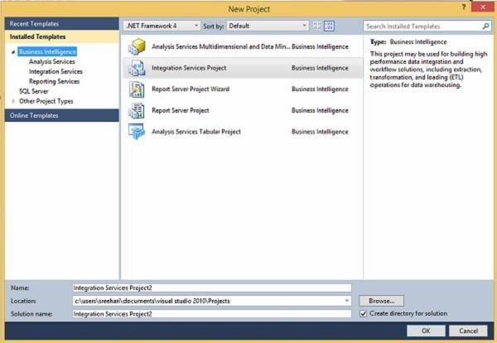
Step 4 − In the above screen, select any one option from the listed five options based on your requirement to work with Analysis services.

ETL Process in Power BI

1) Remove other columns to only display columns of interest

In this step you remove all columns except ProductID, ProductName, UnitsInStock, and QuantityPerUnit
Power BI Desktop includes Query Editor, which is where you shape and transform your data connections. Query Editor opens automatically when you select Edit from Navigator. You can also open the Query Editor by selecting Edit Queries from the Home ribbon in Power BI Desktop. The following steps are performed in Query Editor.
- In Query Editor, select the ProductID, ProductName, QuantityPerUnit, and UnitsInStock columns (use Ctrl+Click to select more than one column, or Shift+Click to select columns that are beside each other).
- Select Remove Columns > Remove Other Columns from the ribbon, or right-click on a column header and click Remove Other Columns.

In this step, you expand the Order_Details table that is related to the Orders table, to combine the ProductID, UnitPrice, and Quantity columns from Order_Details into the Orders table. This is a representation of the data in these tables:
The Expand operation combines columns from a related table into a subject table. When the query runs, rows from the related table (Order_Details) are combined into rows from the subject table (Orders).
After you expand the Order_Details table, three new columns and additional rows are added to the Orders table, one for each row in the nested or related table.
- In the Query View, scroll to the Order_Details column.
- In the Order_Details column, select the expand icon ( ).
- In the Expand drop-down:
  - Select (Select All Columns) to clear all columns.
  - Select ProductID, UnitPrice, and Quantity.
  - Click OK.

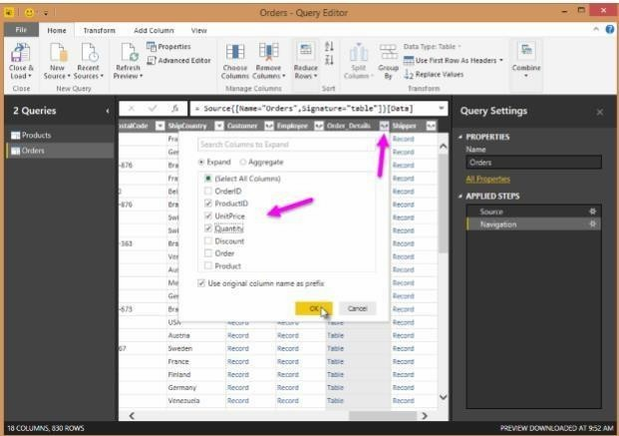

- Calculate the line total for each Order_Details row
Power BI Desktop lets you to create calculations based on the columns you are importing, so you can enrich the data that you connect to. In this step, you create a Custom Column to calculate the line total for each Order_Details row.
Calculate the line total for each Order_Details row:
1. In the Add Column ribbon tab, click Add Custom Column.

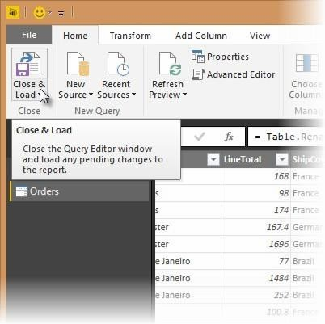

- In the Add Custom Column dialog box, in the Custom Column Formula textbox, enter [Order_Details.UnitPrice] * [Order_Details.Quantity].
- In the New column name textbox, enter LineTotal.
- Click OK.

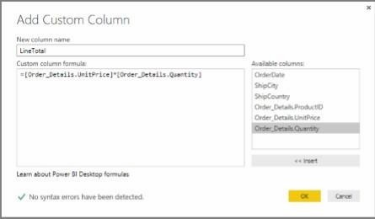
- Rename and reorder columns in the query
In this step you finish making the model easy to work with when creating reports, by renaming the final columns and changing their order.
  - In Query Editor, drag the LineTotal column to the left, after ShipCountry.

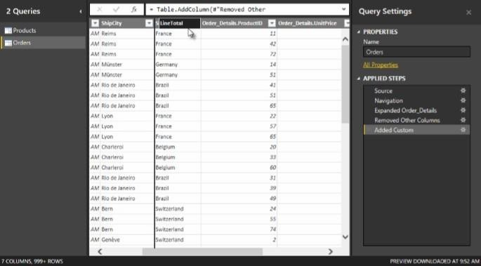

2.Remove the Order_Details. prefix from the Order_Details.ProductID, Order_Details.UnitPrice and Order_Details.Quantity columns, by double-clicking on each column header, and then deleting that text from the column name.
- Combine the Products and Total Sales queries
Power BI Desktop does not require you to combine queries to report on them. Instead, you can create Relationships between datasets. These relationships can be created on any column that is common to your datasets
we have Orders and Products data that share a common 'ProductID' field, so we need to ensure there's a relationship between them in the model we're using with Power BI Desktop.Simply specify in Power BI Desktop that the columns from each table are related (i.e. columns that have the same values). Power BI Desktop works out the direction and cardinality of the relationship for you. In some cases, it will even detect the relationships automatically.
In this task, you confirm that a relationship is established in Power BI Desktop between the Products and Total Sales queries
Step 1: Confirm the relationship between Products and Total Sales
  - First, we need to load the model that we created in Query Editor into Power BI Desktop. From the Home ribbon of Query Editor, select Close & Load.

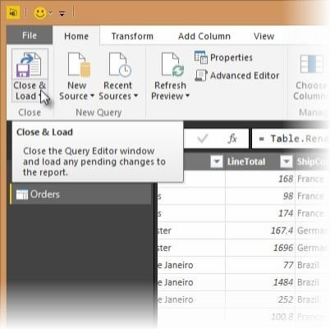

- Power BI Desktop loads the data from the two queries.

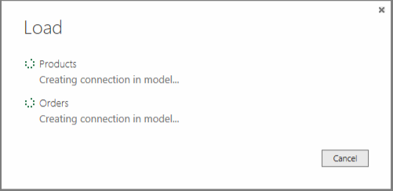
- Once the data is loaded, select the Manage Relationships button Home ribbon.

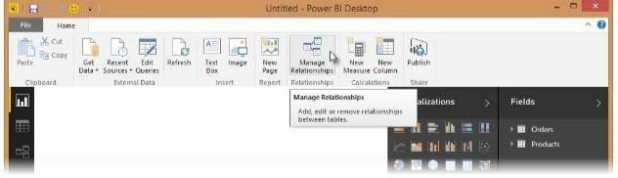

- Select the New… button

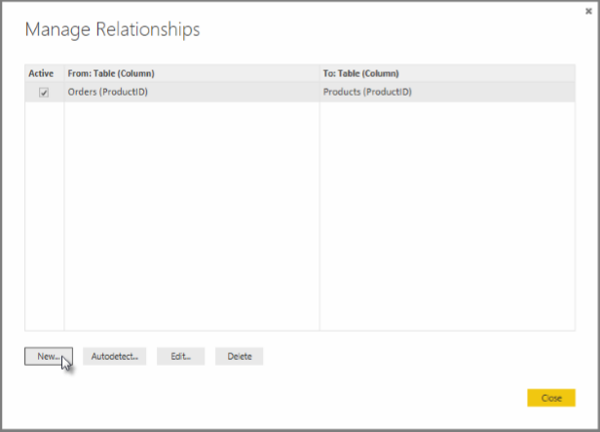

- When we attempt to create the relationship, we see that one already exists! As shown in theCreate Relationship dialog (by the shaded columns), the ProductsID fields in each query already have an established relationship.

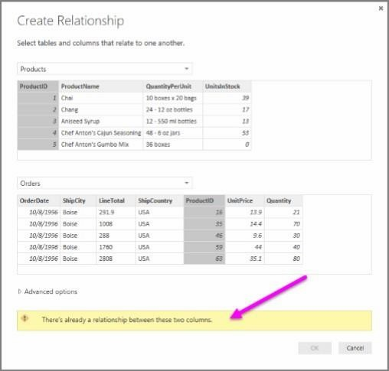

- Select Cancel, and then select Relationship view in Power BI Desktop.

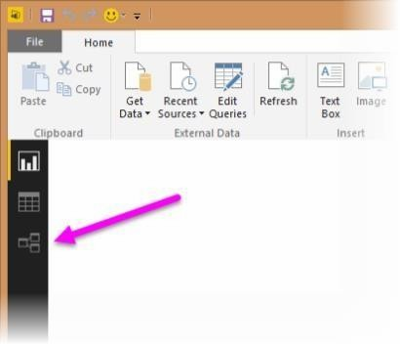
- We see the following, which visualizes the relationship between the queries.

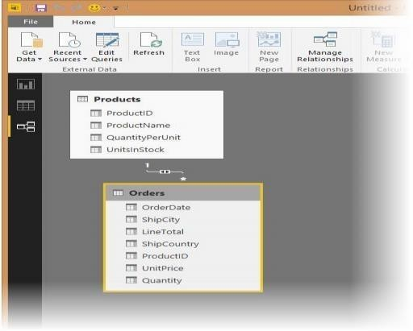

7. When you double-click the arrow on the line that connects to the queries, an Edit Relationship dialog appears.

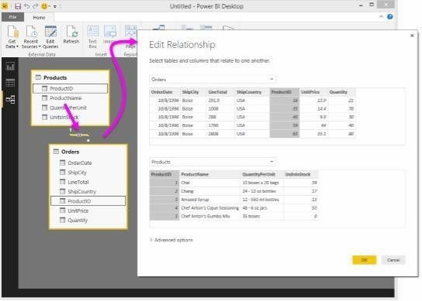

No need to make any changes, so we'll just select Cancel to close the Edit Relationship dialog
Conclusion: Thus Performed Extraction Transformation and Loading (ETL) process to construct the database in the Sql server / Power BI.

